

**ASSIGNMENT COVER PAGE**

**Please fill in all the required details for your assignment to be accepted.**

|  |  |  |  |
| --- | --- | --- | --- |
| Student’s Name | GBENLE KAMOLIDEEN AJIBOLA | | |
| Student’s Matric No | LUC-NGA-001-ADM-1000435 | | |
| Year/Semester | Year 1/ Semester 1 | | |
| Program | Computer Science (Cyber Security & Network Technology) | | |
| Subject Name / Subject Code | Web Technology (WBT-124) | | |
| Lecturer’s Name | Mr. Mansoor | | |
| Assignment Title |  | | |
| No. of Page (excluding this page) |  | | |
| Required words |  | Actual of words |  |
| Soft copy included | Yes / No | | |
| **DECLARATION BY STUDENTS:**  *I certify that this assignment is my own work in my own words. All resources have been acknowledged and the content has not been previously submitted for assessment to LINCOLN or elsewhere. I also confirm that I have kept a copy of this assignment.*  Sign: kamolideen Date: 21/07/2023 | | | |

**ASSIGNMENT**

1. **L**ist with examples, 100 HTML tags.
2. 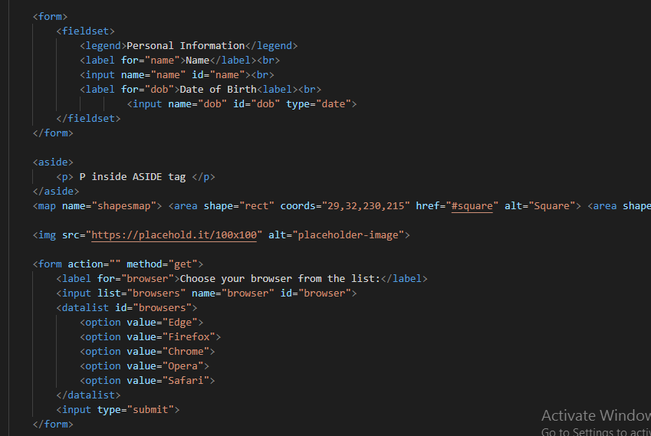Anchor <a href=”#”> </a>
3. Bold <b></b>
4. Break <br/>
5. <big> </big>
6. Comment <!-- -->
7. <caption> </caption>
8. <center> </center>
9. Strikethrough <del> </del>
10. <dl> </dl>
11. <dt> </dt>
12. <dd> </dd>
13. <div></div>
14. <embed/>
15. <font> </font>
16. <frameset> </frameset>
17. <h1></h1>
18. <h2></h2>
19. <h3></h3>
20. <h4></h4>
21. <h5></h5>
22. 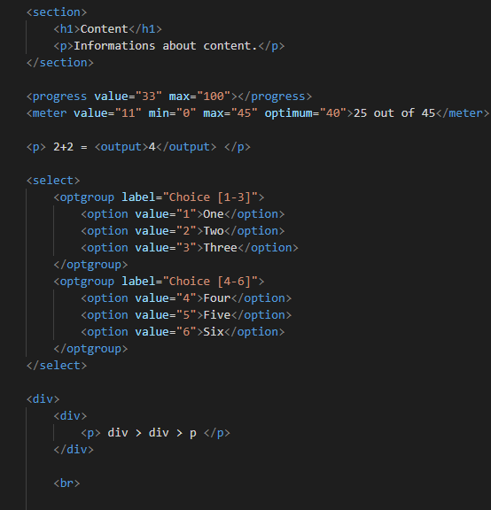<h6></h6>
23. <hr/>
24. <i> </i>
25. <iframe/>
26. <img/>
27. <li> </li>
28. <manquee> </manquee>
29. <ol> <ol>
30. <p> </p>
31. <q> <q>
32. <strike> </strike>
33. <sup> </sup>
34. <sub> </sub>
35. <strong> </strong>
36. <small> </small>
37. <s> </s>
38. <tr> </tr>
39. <td> </td>
40. <table> </table>
41. <th> </th>
42. <u> </u>
43. <mark> </mark>
44. <pre> </pre>
45. 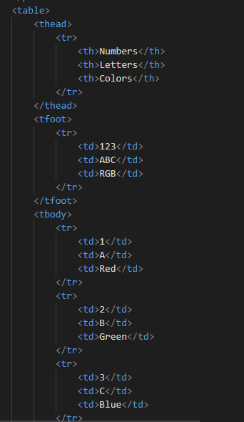<map> </map>
46. <form> </form>
47. <button> </button>
48. <textarea> </textarea>
49. <input/>
50. <style> </style>
51. <object> </object>
52. <figure>
53. <session>
54. <thead>
55. <video>
56. <max>
57. <span>
58. <html>
59. <body>
60. <head>
61. <footer>
62. <address>
63. <label>
64. 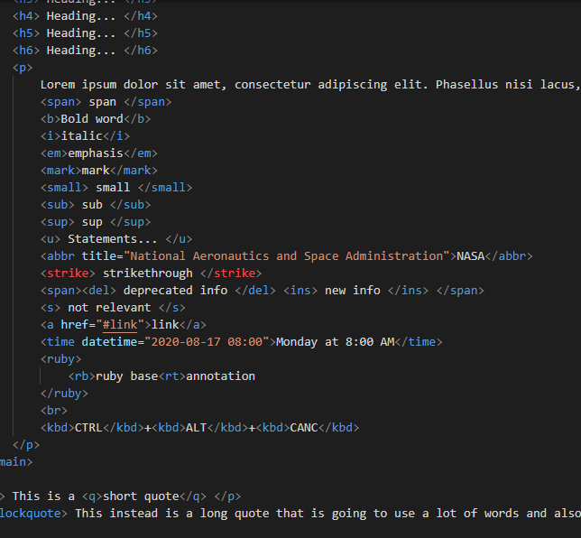<option>
65. <aside>
66. 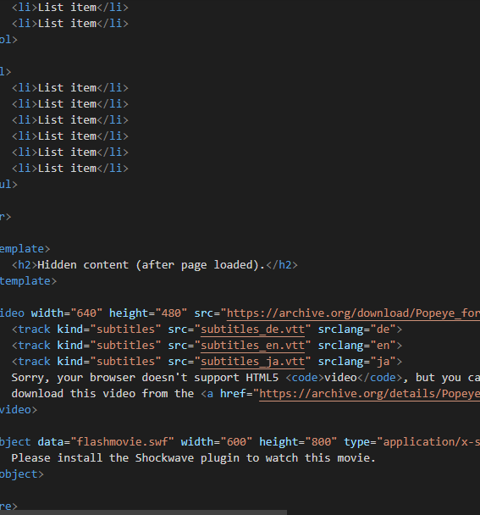<fieldset>
67. What is manifest file in HTML5?

A manifest file is a text file that tells the browser to cache certain files or webpages so that they can be used even in offline mode. HTML5 cache webpages by specifying manifest attribute in <html> tag. All the web pages that contain manifest attributes or are specified in the manifest file will be cached whenever a user visits that page.

1. Write a code to demonstrate Microdata in HTML5

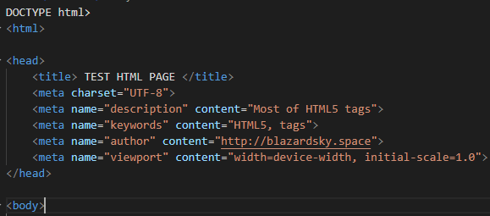

1. Demonstrate how to include video and audio in a webpage



1. What are tags and attribute in html

| **HTML Tags** |  | **HTML Attributes** |
| --- | --- | --- |
| HTML tags are used to hold the HTML element. |  | HTML attributes are used to describe the characteristic of an HTML element in detail. |
| HTML tag starts with < and ends with > |  | HTML attributes are found only in the starting tag. |
| HTML tags are almost like keywords where every single tag has unique meaning. |  | HTML attributes specify various additional properties to the existing HTML element. |